**Employee Salary Portal**

**Flow of portal: -**

1. After clicking Login in navbar, login page will come.
2. In the login page we need to prove Emp Id and Password as credentials also, two radio button will there to login as HR or Employee and a login button.
3. After login this type of dashboard will be there



If user login as HR, then 3 services will be there i.e., get employees details, add employee details, and show salary details of all employees. But if user login as Employee, then the 2 services will be getting his detail only and get his salary detail only.

**Description:-**

1. Common component i.e., visible to any registered or non-registered user: -
2. Navbar
3. Home
4. About
5. Contact
6. Login
7. Footer
8. Page Not Found
9. Component which is visible to only registered user: -
10. Dashboard after login
11. Services (Add, getall, etc.)
12. Icon in Navbar for portal should be there.
13. Type of User Role: -
14. HR
15. Employee
16. Services according to role: -
17. As a HR: -
18. Add employee details.
19. Get all employee details.
20. Update employee details.
21. Inactive employee.
22. As an Employee: -
23. Get your details and inside it we are giving the option to update some details.
24. Salary details in which ae are showing Pay slips.
25. **Add employee details services when as a HR do login: -**

Details to be added from Front-End are given below: -

1. Emp Id
2. First Name
3. Middle Name
4. Last Name
5. DOB
6. Country Code
7. Contact
8. Alternative Contact Number
9. Address
10. Aadhar Number
11. Pan Card
12. Designation
13. Salary
14. Date of Joining
15. Email Id
16. Work Location
17. Bank Name
18. Account Number
19. IFSC Code

Details to be added from Back-End are given below: -

1. All above fields
2. Creation Date
3. In Active flag with ‘Y’ value
4. **Get all employee details services when as a HR do login: -** When HR click on get all services following details will be shown with 2 buttons of update and inactive.
5. S. No.
6. Emp Id
7. First Name
8. Middle Name
9. Last Name
10. DOB
11. Country Code
12. Contact
13. Alternative Contact Number
14. Address
15. Aadhar Number
16. Pan Card
17. Designation
18. Salary
19. Date of Joining
20. Email Id
21. Work Location
22. Bank Name
23. Account Number
24. IFSC Code
25. **When HR Click on Update services: -** All fields will come for update except following fields which will be grey out: -
26. Emp Id
27. DOB
28. Date of Joining

Details to be added from Back-End are given below: -

1. S. No.
2. Emp Id
3. First Name
4. Middle Name
5. Last Name
6. DOB
7. Country Code
8. Contact
9. Alternative Contact Number
10. Address
11. Aadhar Number
12. Pan Card
13. Designation
14. Salary
15. Date of Joining
16. Email Id
17. Work Location
18. Bank Name
19. Account Number
20. IFSC Code
21. Modification Date
22. **Only HR have the authority to make employee inactive and Date of Resignation will be on the date when HR makes employee inactive.**
23. **When HR Click on Inactive employee services: -** Date of Resignation will be on the date when HR makes employee inactive. Also, employee access to login in this portal will be revoked and In Active flag should change to ‘N’ value.
24. **Get your details services when as an employee you do login: -**

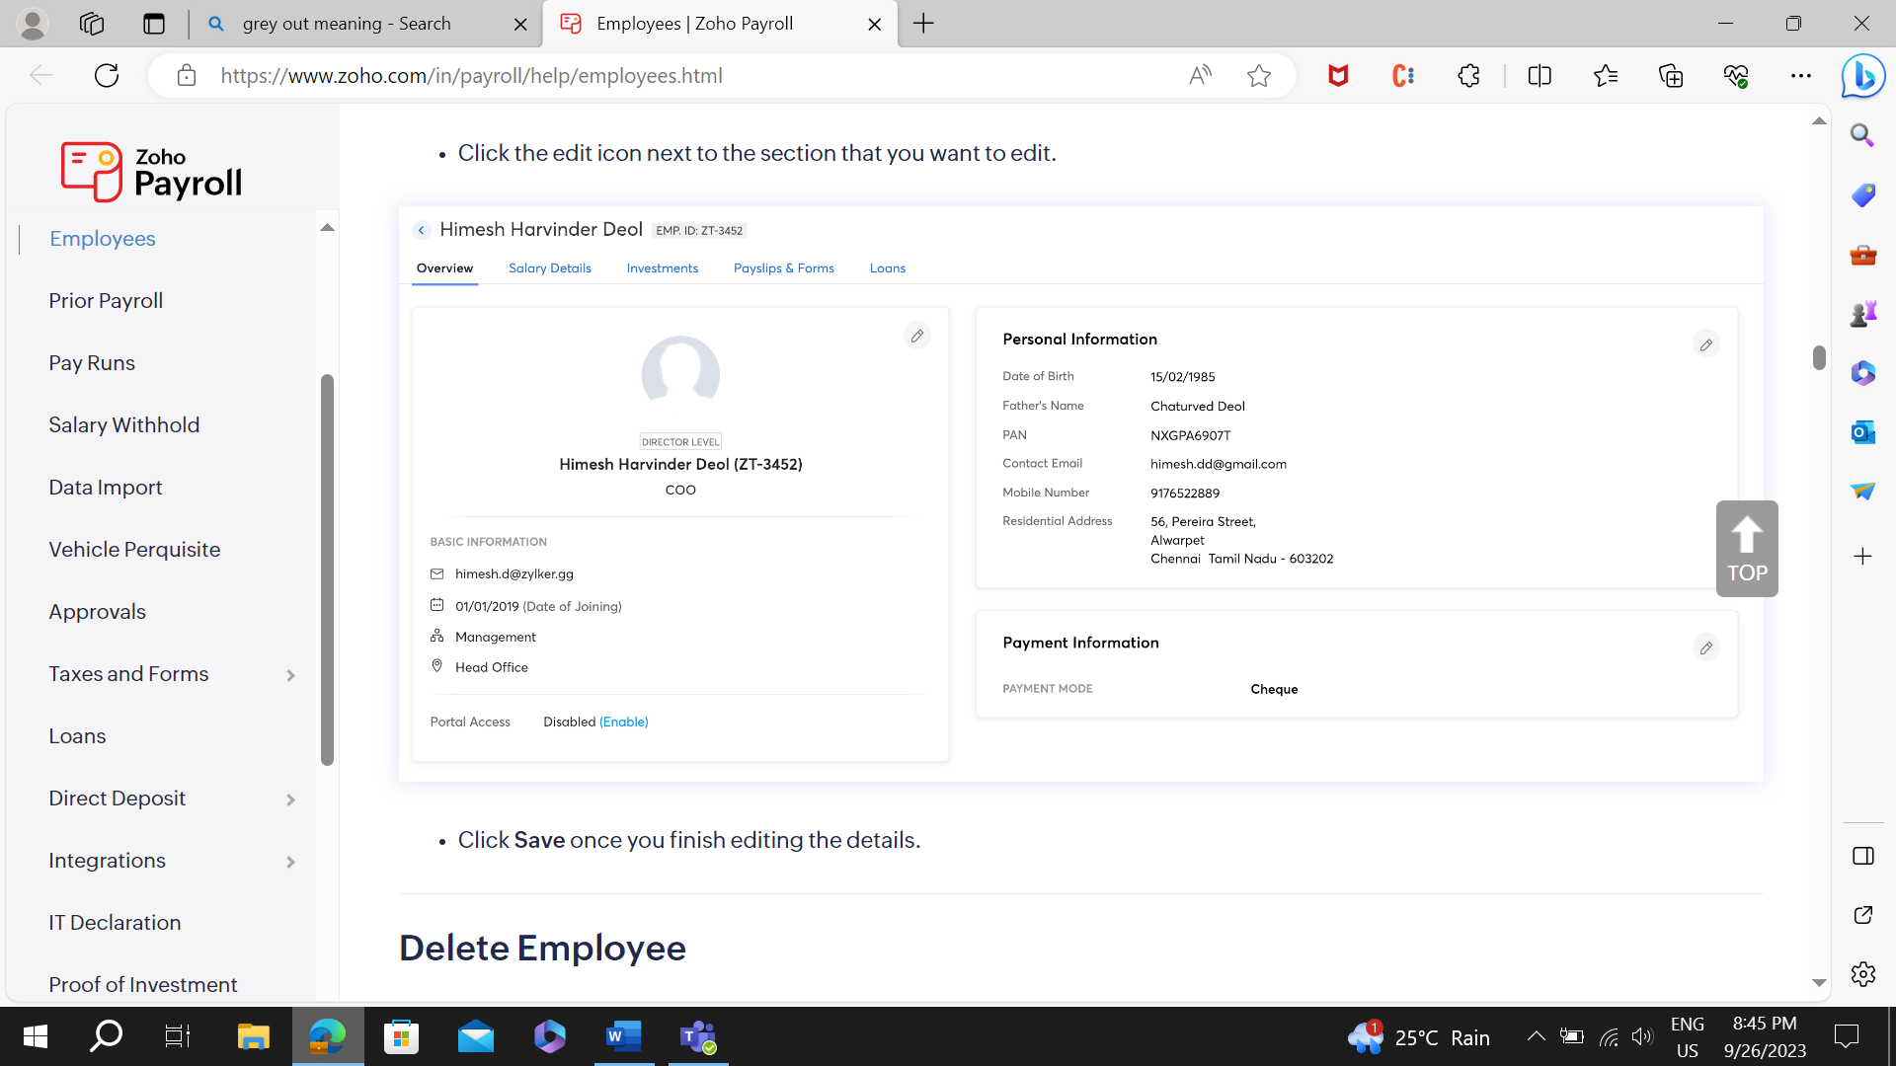

Like above we need to include when employee click on get your details services except payment information and in place of disable-enable we need to use Active keyword to show status of employee.

1. **Update your services when as an employee you do login: -**

Only below field employee can update: -

1. First Name
2. Middle Name
3. Last Name
4. Email ID
5. Contact
6. Address

**Database Details: -**

1. M_Emp_Dtl table: -
2. Emp Id 🡪 Primary and unique
3. First Name
4. Middle Name
5. Last Name
6. DOB
7. Country Code
8. Contact
9. Alternative Contact Number
10. Address
11. Aadhar Number
12. Pan Card
13. Designation
14. Salary
15. Date of Joining
16. Date of Resignation
17. Email Id
18. Work Location
19. Bank Name
20. Account Number
21. Creation date
22. Modification Date
23. IsActive
24. M_Addr_Dtl table: -
25. Emp Id 🡪Foreign Key
26. Country
27. State
28. District
29. City
30. Pin Code
31. Address
32. T_Salary_Dtl table: -
33. Emp Id 🡪Foreign Key
34. Salary ID 🡪 Primary Key
35. Bank Name
36. Account Number
37. Gross pay
38. Net pay
39. Total deduction
40. IsActive
41. M_Bank_Dtl table: -
42. Bank Id 🡪 Primary Key
43. Bank Name
44. IFSC Code
45. IsActive

**Future Scope: -**

1. Checker Maker
2. Registration Page
3. Leave Managment